Image | 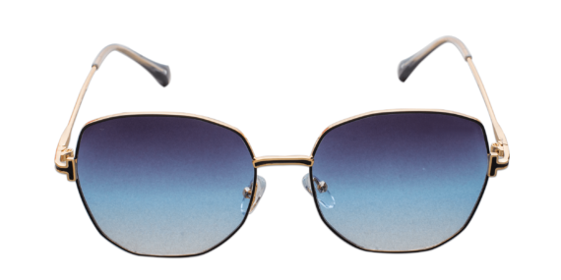
Brand | TOM FORD
Model Name | Epitome PSG
Price | RS 2000
PRODUCT DETAILS

